

Business Template

Staging Layer vs 3NF
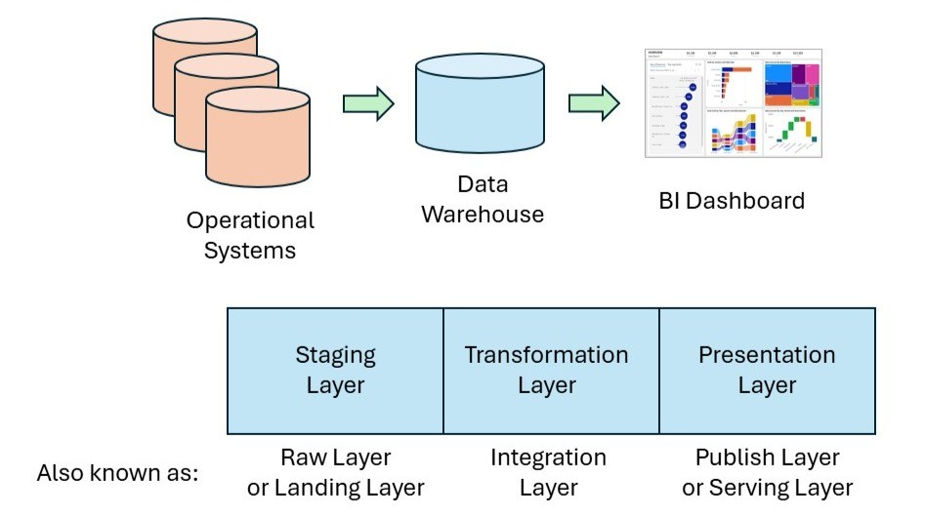

Purpose of the Staging Area
The staging area in a data warehouse is an intermediate storage layer where raw data from multiple source systems is initially loaded before further processing. The main purposes include:
1. Landing / Ingestion
- It is the first place data lands after extraction from source systems.
- Supports loading large volumes of raw, unprocessed data.
2️. Data Cleansing
- Source systems are often dirty or inconsistent.
- The staging area is where initial data validation, error detection, and basic cleaning occur.
3️. Transformation Preparation
- Raw data often comes in different formats, structures, or coding schemes.
- In staging, data can be standardized and reformatted in preparation for transformation.
4️. Auditing & Debugging
- Keeping the raw snapshot in staging allows you to trace and audit what was loaded from the source.
- If a downstream load fails, you don't have to go back to the live source system to re-extract it.
5️. Handling Late-Arriving Data
- The transcript describes late-arriving facts and dimensions (e.g. sales data, roaming calls).
- Staging helps manage these by reloading recent periods (like the last 3 months) to ensure completeness.
6️. Decoupling Source Systems from DW
- The staging area insulates the source systems from frequent re-extracts, reducing load on operational systems.

Why you can't load directly into the 3NF layer
Short answer: Because the raw source data is not ready or clean enough for the highly structured 3NF layer.
1️. Source Systems Are Dirty / Inconsistent
- The 3NF layer enforces strong consistency and integrity—data must be clean before it lands there.
2️. Conformance of Data
- Different source systems might describe the same thing differently (e.g. product IDs, customer codes).
- Staging is needed to conform these into a single, unified dimension.
3️. Transformation Complexity
- The transformation needed to get data from raw source to 3NF (joining, deduplication, SCD handling, business rules) is too big to do “on the fly” during load.
- Staging gives you a working area to break the process into manageable steps.
4️. Audit & Error Recovery
- If you skip staging and a load into 3NF fails halfway, you have no copy of the raw data to restart from.
- Staging ensures repeatable, reliable ETL.
5️. Handling Late-Arriving Data
- Staging enables reloading and reconciliation for these late updates.
6️. Source Data Volume and Shape
- Source extracts can be huge, denormalized, or in very different shapes than the normalized 3NF model.
- Staging is where these are reshaped to fit.

